Exercise: Appcelerator
Document Number: |  | Issue Number:  Date:

Exercise 1: Get Started with the first simple app

Description
The purpose of this exercise is to get familiar with Titanium Studio, how to create project with the most basic structure.
Note: This demo runs on OS X 10.8 to work with iPhone simulator

Create new Project.
Open Titanium Studio, create new project with default project.
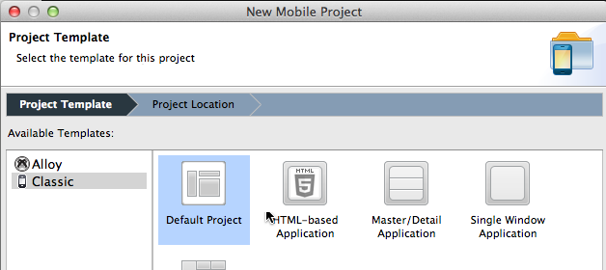
Provide the project name as ‘AppDemo’. Select deployment target as iPad & iPhone.
Enable the checkbox ‘Cloud-enable this application’

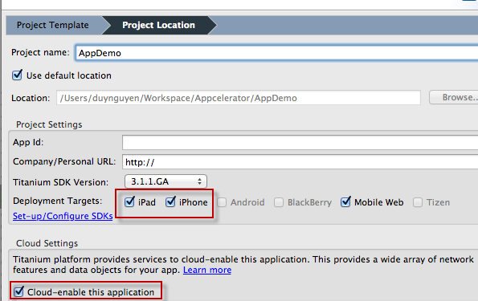
Then click Finish.

Create the project file structure
- There already exists app.js file generated by Titanium studio in Resource folder. Add 3 more javascript files named contacts.js, favorites.js, maps.js for using in the next exercises below.
- Create new folder ‘images’ in Resource folder to store the app images, if used
- Create new folder ‘database’ in Resource folder to store the local database files, if used
The overall structure will look like the image below
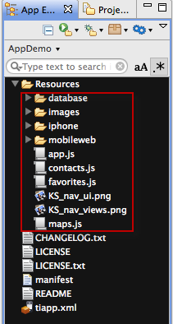

Modify tab control
- Titanium already generated in app.js a TabGroup which contains 2 windows in each tab. Now we adjust the code in app.js so that the app contains 3 tab controls for Contacts, Favorites and Maps window.
- Clear all the generated code in app.js
- Create UI for Contacts, Favorites and Maps screen
var win1 = Titanium.UI.createWindow({
title : 'Contacts',
backgroundColor : '#fff',
url : 'contacts.js'
});
var tab1 = Titanium.UI.createTab({
icon : 'KS_nav_views.png',
title : 'Contacts',
window : win1
});

var win2 = Titanium.UI.createWindow({
title : 'Favorites',
backgroundColor : '#fff',
url : 'favorites.js'
});
var tab2 = Titanium.UI.createTab({
icon : 'KS_nav_ui.png',
title : 'Favorites',
window : win2
});

var win3 = Titanium.UI.createWindow({
title : 'Maps',
backgroundColor : '#fff',
url : 'maps.js'
});
var tab3 = Titanium.UI.createTab({
icon : 'KS_nav_ui.png',
title : 'Maps',
window : win3
});

- Create the tabGroup and add 3 child tabs inside it
// add tabs
tabGroup.addTab(tab1);
tabGroup.addTab(tab2);
tabGroup.addTab(tab3);
// open tab group
tabGroup.open();

Run the app

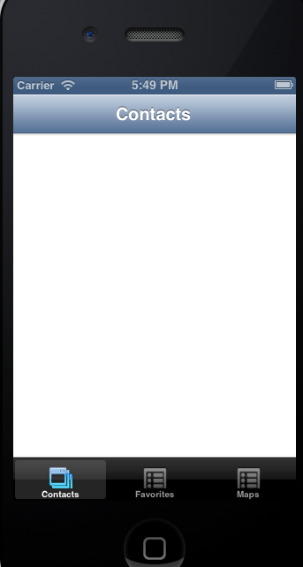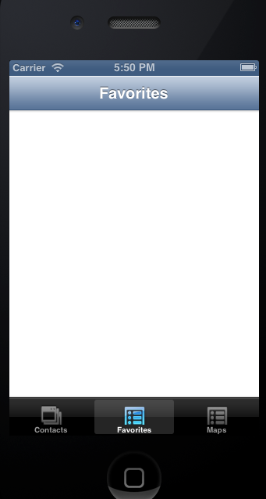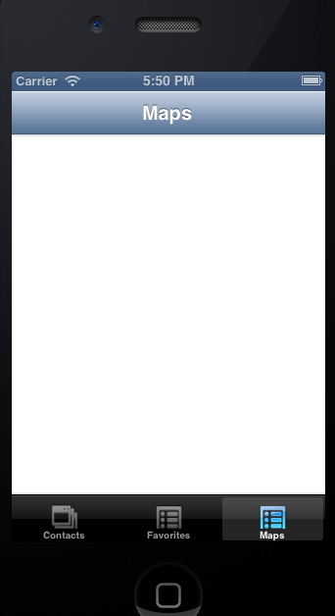

Exercise 2: Create a Contacts Page

Description.
The purpose of this exercise is to help students get familiar with some basic UI controls, events handling and remote storage by using HttpClient object.

Working with remote data storage
We store the contact list data in JSON file somewhere in the web. Create HttpClient object which reads the data from the remote location.
//declare the http client object
var xhr = Titanium.Network.createHTTPClient();
//this method will process the remote data
xhr.onload = function() {
//alert(this.responseText);
var json = JSON.parse(this.responseText);
Ti.API.info(this.responseText);
};
//this method will fire if there's an error in accessing the //remote data
xhr.onerror = function() {
//log the error to our Titanium Studio console
Ti.API.error(this.status + ' - ' + this.statusText);
alert('error');
};
//open up the recipes xml feed
xhr.open("GET", "http://20.203.144.25:8022/contacts.txt");
//finally, execute the call to the remote feed
xhr.send();

Create the Contact List using TableView
We use TableView to display the Contact List. It contains a set of TableViewRow objects in which the data display is handled in xhr.onload() event.
The data returned from the remote location is the text file with Json format, so call JSON.parse() method to handle the data simply.
- Create the Table View and add it to current window
var tblContacts = Titanium.UI.createTableView({
width : Titanium.Platform.displayCaps.platformWidth,
height : Titanium.Platform.displayCaps.platformHeight,
height : 366,
width : 320,
top : 0,
left : 0,
rowHeight : 70,
search : search,
filterAttribute : 'filter'
});
win.add(tblContacts);

- In onload() callback function, loop for each data returned in JSON format to create a set of TableViewRow. Then set data property of TableView object by this set of TableViewRow.
//this method will process the remote data
xhr.onload = function() {
//alert(this.responseText);
var json = JSON.parse(this.responseText);
Ti.API.info(this.responseText);
//alert(jsonObj.contacts.length);
for (var i = 0; i < json.contacts.length; i++) {
//create table row
var row = Ti.UI.createTableViewRow({
hasChild : true,
backgroundColor : '#fff',
filter : json.contacts[i].name,
_name : json.contacts[i].name,
_address : json.contacts[i].address
});

//title label
var lblName = Ti.UI.createLabel({
text : json.contacts[i].name,
font : {
fontSize : 14,
fontWeight : 'bold'
},
top : 5,
left : 70,
height : 20,
width : 210,
color : '#000'
});

var lblDesc = Ti.UI.createLabel({
text : json.contacts[i].address,
font : {
fontSize : 10,
fontWeight : 'normal'
},
top : 25,
left : 70,
height : 40,
color : '#000'
});

var icon = Ti.UI.createImageView({
image : 'images/logo.gif',
top : 10,
left : 10,
width : 50,
height : 50
});

row.add(lblName);
row.add(lblDesc);
row.add(icon);
data.push(row);
}

//Add data to table
tblContacts.data = data;
};

Test the Contact page
Run the application in iPhone simulator
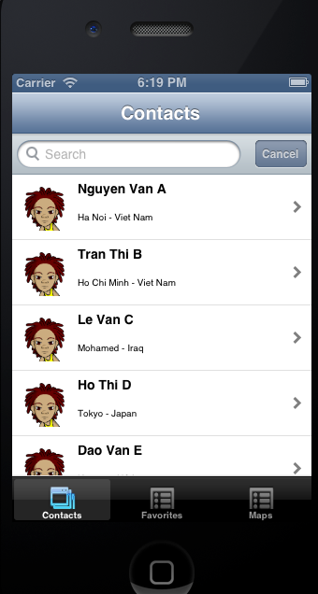

Homework
- In Contacts page, add the Search function as image above to filter the contacts base on input text.
- Modify the json data for more informations, then update the layout for each TableView row with more informative data, like icon, mail, phone number...

Exercise 3: Create detail page with Saving favorites option.

Description
The purpose of this exercise is make students get familiar with how to transfer from page to another page. This practice also mention about the way of creating and saving to local database storage.

Click on one item to transfer to another page
In click() event of tblContacts, create a detailWindow which stores the detail information of select row. Create a label to show the address and a favorite button which will allow use to save data to database storage.
Then transfer to detail Window via Ti.UI.currentTab.open() method.
//pop up new window once clicking on table row
tblContacts.addEventListener('click', function(e) {
var selectedRow = e.rowData;
var detailWindow = Ti.UI.createWindow({
title : selectedRow._name,
_address : selectedRow._address,
backgroundColor : '#fff',
id : 0
});

var lblDescription = Titanium.UI.createLabel({
text : detailWindow._address,
left : 10,
top : 20,
width : 300,
height : 'auto',
color : '#000'
});
detailWindow.add(lblDescription);

//add a favorite button
var favButton = Ti.UI.createButton({
title : 'Add Favorite',
top : 50,
left : 10,
width : 150,
height : 'auto',
isAdded : 0
});
//open the detail window
Ti.UI.currentTab.open(detailWindow);
});

Create local database storage.
Database in Appcelerator Titanium is simply a javascript file, in which we can handle CRUD command for data manipulation.
- In database.js, create database name mydb
//create a database object
var db = Ti.Database.open('mydb');
db.execute('CREATE TABLE IF NOT EXISTS favorites(ID INTEGER PRIMARY KEY AUTOINCREMENT, NAME TEXT, ADDRESS TEXT)');

- In database.js, add 2 functions for adding and delete favorites item.
function insertFavorite(name, address) {
var sql = "INSERT INTO favorites (name, address) VALUES (";
sql = sql + "'" + name.replace("'", "''") + "', ";
sql = sql + "'" + address.replace("'", "''") + "')";
db.execute(sql);
return db.lastInsertRowId;
}

function deleteFavorite(id) {
var sql = "DELETE FROM favorites WHERE id = " + id;
db.execute(sql);
}

Save and delete favorite
Handle the click() event of favButton to save/delete the favorite into/from mydb database.
//favButton event click
favButton.addEventListener('click', function(e) {
if (favButton.isAdded == 0) {
var newId = insertFavorite(detailWindow.title, detailWindow._address);
Ti.API.info('Inserted successfully' + newId);
detailWindow.id = newId;
alert('Added to favorites');
favButton.isAdded = 1;
favButton.title = 'Remove favorite';
} else {
deleteFavorite(detailWindow.id);
//Ti.API.info('Deleted ' + affectedRows + ' favorite records. (id ' + detailWindow.id + ')');
detailWindow.id = 0;
alert('This contact has been removed from favorites!');
favButton.added = 0;
favButton.title = 'Add Favorite';
}
});

Run the details page in iPhone simulator
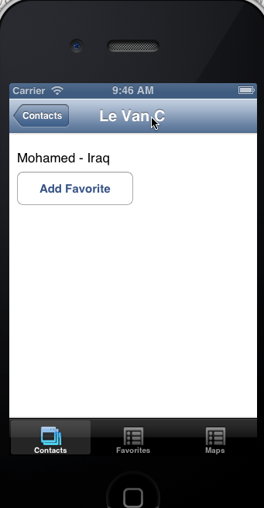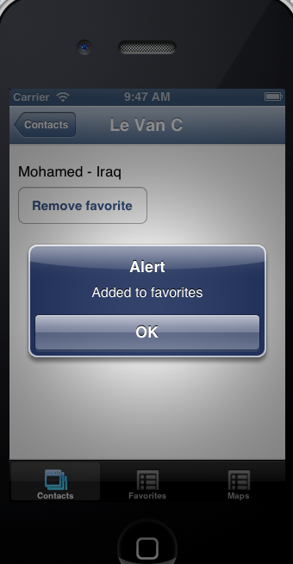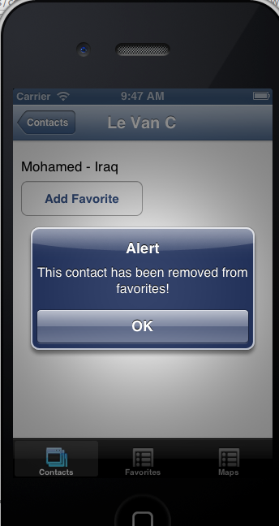

Homework
- Update the Detail Page with more informative data, based on the json file adjusted in Homework 2.5
- Update the code so that, we can Add Favorite if it doesnot exist in database. Otherwise, display Remove Favorite in initial loading.

Exercise 4: Create Favorites page.

Description
The purpose of this exercise is make students get familiar with how to use RecordSet returned from SELECT statement in mydb local database storage.

Create function to return list of favorites items
In database.js, create one more function named getFavorites()

function getFavorites(){
var sql = "SELECT * FROM favorites ORDER BY name ASC";
var results = [];
var rs = db.execute(sql);
while (rs.validRow){
results.push({
id: rs.fieldByName('id'),
name: rs.fieldByName('name'),
address: rs.fieldByName('address')
});
rs.next();
}
//Must close the result set
rs.close();
//return data
return results;
}

Load favorites data in Favorites page
Same as previous practice, create a table view as a container, named tblFav.
Create an array data[] to store set of TableViewRow. Which will be set to data property of tblFav table view.
var win = Ti.UI.currentWindow;
var data = [];
//create table view
var tblFav = Ti.UI.createTableView({
title : 'Favorites',
top : 50,
left : 0,
height : 'auto'
//backgroundColor: '#fff'
});

function loadTable() {
data = [];
rows = [];
var data = getFavorites();

for (var i = 0; i < data.length; i++) {
var row = Ti.UI.createTableViewRow({
backgroundColor : '#fff'
});
var lblName = Ti.UI.createLabel({
text : data[i].name,
font : {
fontSize : 14,
fontWeight : 'bold'
},
top : 5,
left : 70,
height : 20,
width : 210,
color : '#000'
});
row.add(lblName);
rows.push(row);
}
tblFav.data = rows;
}

Call the loadTable() method in focus() event of current window to show the data.
win.addEventListener('focus', loadTable);

Test the Favorites page in iPhone simulator
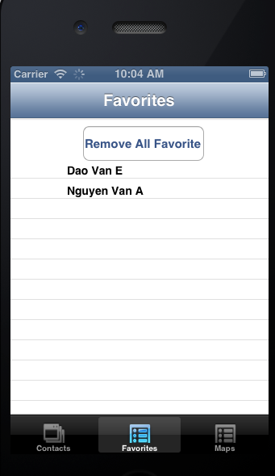

Homework
- In each row, add a button named [Remove Fav] to remove the row item out of database. Then reload the page.
- Create a Remove All button at the top of page to remove all favorites
- If no favorites stored in database, show a message

Exercise 5: Create Maps page.

Description
The purpose of this exercise is make students get familiar with how to work with Map View and some basic API such as Geolocation.

Create an initial map view
//create a map view
var mapView = Ti.Map.createView({
top : 81,
height : 450,
mapType : Ti.Map.STANDARD_TYPE,
region : {
latitude : 51.50015,
longitude : -0.12623,
latitudeDelta : 0.5,
longitudeDelta : 0.5
},
animate : true,
regionFit : true,
userLocation : true
});

Set the current position and focus to its regions
//set the distance filter
Titanium.Geolocation.distanceFilter = 10;
//apple now requires this parameter so it can inform the user //of whyyou are accessing their location data
Ti.Geolocation.purpose = "To obtain user location for tracking distance travelled.";
Titanium.Geolocation.getCurrentPosition(function(e) {
if (e.error) {
//if mapping location doesn't work, show an alert
alert('Sorry, but it seems geo location is not available on your device!');
return;
}
//get the properties from Titanium.GeoLocation
var longitude = e.coords.longitude;
var latitude = e.coords.latitude;
var altitude = e.coords.altitude;
var heading = e.coords.heading;
var accuracy = e.coords.accuracy;
var speed = e.coords.speed;
var timestamp = e.coords.timestamp;
var altitudeAccuracy = e.coords.altitudeAccuracy;
//apply the lat and lon properties to our mapview
mapView.region = {
latitude : latitude,
longitude : longitude,
latitudeDelta : 0.5,
longitudeDelta : 0.5
};
alert(e.latitude);
});

Create Search View layout
Create a search view which allow users to input an address, then click search button to focus the map to the input region.
//create the search view
var searchview = Titanium.UI.createView({
top : 0,
left : 0,
width : 320,
height : 80,
backgroundColor : 'black'
});
//style it up a bit
var bottomBorder = Titanium.UI.createView({
height : 1,
width : 320,
left : 0,
bottom : 0,
backgroundColor : '#000'
});
searchview.add(bottomBorder);
//add a search box for starting location
var txtStartLocation = Titanium.UI.createTextField({
backgroundColor : '#fff',
left : 10,
top : 20,
width : 200,
height : 30,
borderColor : '#000',
borderRadius : 5,
hintText : 'Current Location',
paddingLeft : 10
});
searchview.add(txtStartLocation);
//add the button with an empty click event, this will fire off
//our forwardGeocoder
var btnSearch = Titanium.UI.createButton({
title : 'Search',
width : 80,
height : 30,
top : 20,
right : 10,
//backgroundImage : 'images/map_bg.jpg',
borderRadius : 3
});
searchview.add(btnSearch);
win.add(searchview);
win.add(mapView);

Using Geolocation API to get the coordinator by the input address
Make use of Geolocation.forwardGeocoder() in click() event of btnSearch button.
//btnsearch event listener fires on button tap
btnSearch.addEventListener('click', function(e) {
txtStartLocation.blur();
if (txtStartLocation.value != '') {
Ti.Geolocation.forwardGeocoder(txtStartLocation.value, function(e) {
//alert(txtStartLocation.value);
mapView.region = {
latitude : e.latitude,
longitude : e.longitude,
latitudeDelta : 0.4,
longitudeDelta : 0.4
};
});

} else {
alert('You must provide a start address!');
}
});

Homework
- In Search View, create one more input text for destination address.
- Change the btnSearch onclick() function to calculate the distance between the starting address and destination address. Show the markers for both address and set the zoom size properly to fit the map.
- Optional: Draw the driving path from the starting point to the destination point.

